Specification for laboratory bucket for crosslinking XLPE type materials.

TFK Requirements:
Thermo-cubicle for crosslinking XLPE type materials in hot water. The bucket must be equipped with two temperature- and time-independent chambers, lockable from the top.
- Automatic heating and shutdown of the tub for efficient work scheduling with new automatic on and automatic off.
- Simplified parameter setting and monitoring with a simple icon-based controller interface.
- Audible alarm, adjustable digital overheat protection, low level detection and high temperature cut-off.
- Ability to save settings (presets) for given materials (time and temperature)
- UL Listed; US FDA Class I Medical
- CE marking
- Dual chamber - 1 chamber 5 liter, 2 chamber 10 liter
- Temperature range up to 100 deg C
- Temperature stability ±0.1°C / ±0.2°C
- Dimensions (approximately) 392 x 590 x 240
- Power 300W for 1st chamber, 800W for 2nd chamber
- Chamber trays for easy sample placement and extraction

Overview photo:
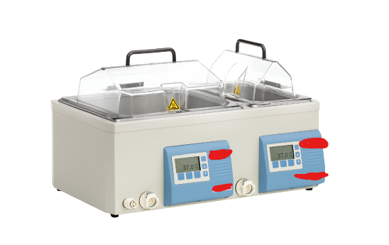
Date of specification preparation: 08.05.2024
Contact person:
Jakub Węgrzyn, Manager Projektów jakub.wegrzyn@tfkable.com
Osoba ds. organizacyjnych: Andrzej Sobala andrzej.sobala@tfkable.com
Ocena techniczna: Michele Sirigiano, Z-ca Kierownika Kontroli Jakości michele.sirignano@tfkable.com

