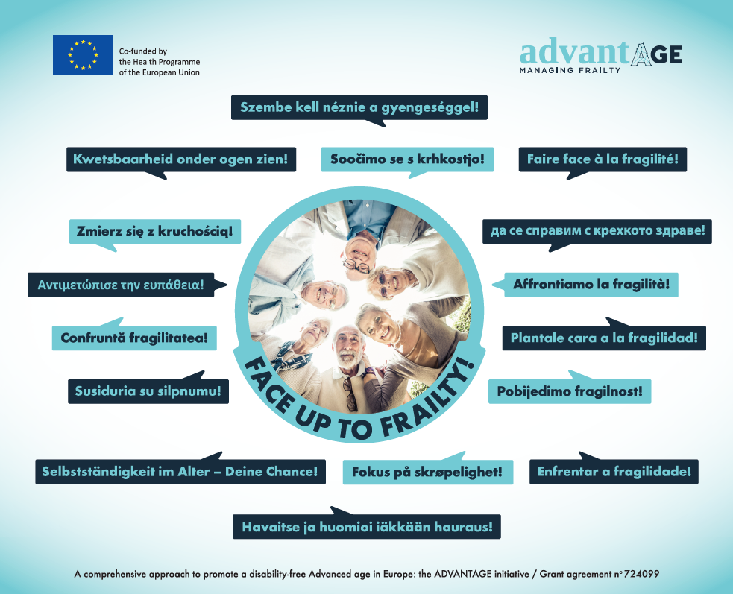

ADVANTAGE JA “Face up To Frailty!“ campaign

GUIDE ON IMPLEMENTATION FOR PARTNERS
and across all sectors (e.g. health, social, and voluntary sector)

Contents
Introduction 3
Context 3
Aims of the #faceuptofrailty campaign 3
How can you contribute to the campaign 4
Materials for the Face Up to Frailty! campaign 4
Interviews (text or video) 4
Example of questions for conducting interviews with people living with frailty: 5
Example of questions for conducting interviews with professional/policy makers/civil society representatives: 6
Photos 7
Short stories 7
Other 8
Face Up to Frailty dissemination materials 8
Dissemination of the material produced by the partners 8
Notes: 9
Campaign website: 9
Annex 1 – Logo translations 10
Annex 2 – Example letter 11
Annex 3 – Photowall 12
Annex 4 – Posters 12
Annex 5 – QR code leaflet 14

Introduction
ADVANTAGE is the first Joint Action tackling frailty in older people at European level. It involves 22 Member States (MS) and 33 organizations. ADVANTAGE is co-funded by the European Union and the MS. Partners work together to build a common understanding on frailty to be used by participating MS.
Frailty is defined as a state of extreme vulnerability that exposes the individual to a higher risk of negative health-related outcomes, increasing the risk of disability, hospitalization or even death.
Frailty is an important public health issue which may be prevented and treated to foster a longer and healthier life. We need to create awareness in the civil society at large and more specifically on health policy makers, people living with frailty, informal carers, health professional and researchers on the relevance and necessity of taking action on this issue.
In order to increase awareness about frailty the Face-up to Frailty Campaign was created by WP1 and started in Spain (June 2018) and UK (October 2018). Then it was launched at European level during the ADVANTAGE JA Madrid Forum on December 13th 2018. Through the “Face-up to Frailty” (#faceuptofrailty) campaign we aim to raise awareness and concern about frailty and to engage people from Europe to take action!
These guidelines have been developed to clearly explain the context and aim of the campaign and provide examples of the materials that may be produced during the campaign. The objective is to increase the participation of partners and other organisations in the #faceuptofrailty campaign.

Context
The #faceuptofrailty campaign target audience consists of policy and decision makers, professionals of the health and social sector and citizens because only by acting at all levels we can integrate the concept of frailty into our communities and create practical solutions for those in need. We need a collaborative approach with the involvement and commitment of all stakeholders for proper dissemination of our campaign message.

Aims of the #faceuptofrailty campaign
- To give visibility to the ADVANTAGE JA recommendations among the health workforce, policy makers, managers, and older people and their carers.
- To have social sector contribution to implementing ADVANTAGE JA recommendations and have tangible results in everyday life, thus putting knowledge and evidence into practice.
- To raise awareness of the impact of frailty for individuals, their families, communities and systems.
- To raise awareness of best practices in tackling frailty around Europe and to Support the adopting of local initiatives at European Level.
- To support people to share their stories about living with frailty.
- To help people from all sectors to understand what they can do to prevent and manage frailty.

How can you contribute to the campaign
During the #faceuptofrailty campaign partners should develop materials (photos, narratives, videos, interviews, etc.) with people who would like to share their thoughts on frailty, or have experienced it, with their families and carers. Partners should also encourage the involvement of other organisations and entities in developing similar material. This is at the heart of a “Face-up to Frailty” engagement campaign directed towards policy makers, advocates, professionals, people living with frailty and cross sector organizations in the 22 Member States involved in the ADVANTAGE JA.
There are different ways you can contribute to the dissemination and content of the #faceuptofrailty campaign:
- Share the invitation to participate in the campaign with your colleagues and/or other people who you think may be interesting in it.
- Share the invitation to participate in the campaign with other organisations who may be interesting in it.
- Contribute by sending content to be uploaded on the ADVANTAGE JA “Face Up to Frailty” section of the website or on the JA social media.
- Highlight to info@advantageja.eu other national or international campaigns that aim to tackle frailty!

Materials for the Face Up to Frailty! campaign
You can develop the following materials to contribute to the #faceuptofrailty campaign. Examples for each type of material are included, for your guidance.

Interviews (text or video)
- Interviews with a person/people who experience frailty (video or text). Interviews can be conducted in your own language. If you want, you can also provide an English translation. On the website of the campaign both language versions (if English is provided) will be posted.
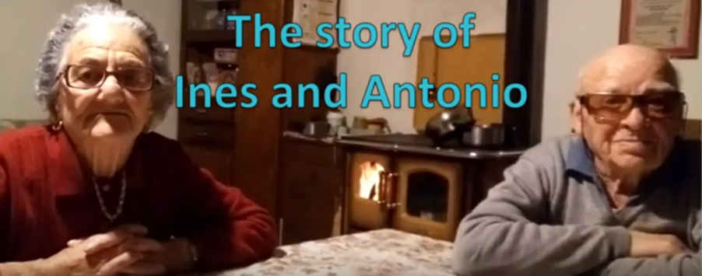  Click here to watch the interview. | 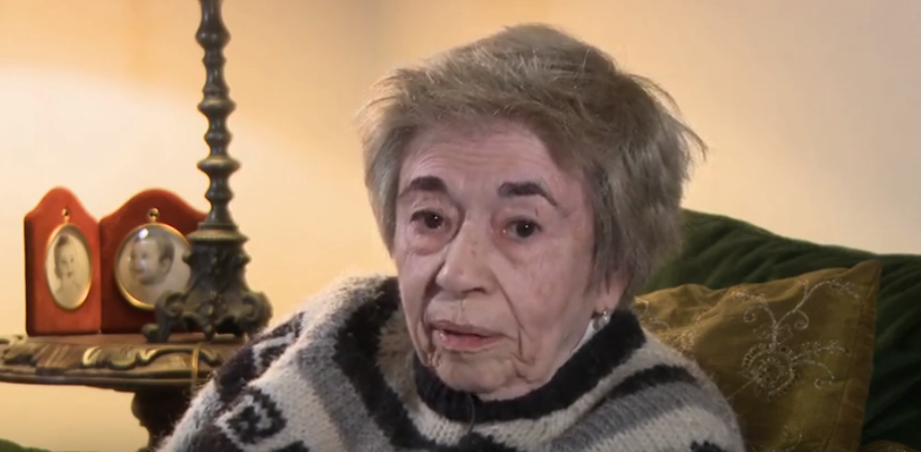  Click here to watch the interview.
- Interviews with carers of people living with frailty (video or text)
- Interviews with policy maker, or civil society representative who are working to tackle the problem of frailty (video or text)
For an example of an interview please click here

- Interviews with professionals working with people living with frailty (Interviews with carers of people living with frailty) click here

Example of questions for conducting interviews with people living with frailty:
- What does “frailty” mean to you?
- Do you consider yourself as living with frailty?
If the answer is yes:
- What is the impact of frailty on your life?
- Do you feel recognised for what you can do, rather than assumptions being made about what you cannot do?
- Do you feel you can make your own decisions, with advice and support from family, friends or professionals if you want it?
- Compared to 10 years ago, what’s your life like? Do you feel different?
- Have there been any changes in daily or leisure activities since 10 years ago?
- Why do you think these changes took place?
- Does this condition have a significant impact on your life?
- Can you do activities that are important to you?
- How do you cope with these changes?
- Do you feel supported to be independent?
- How does your social life look like?
- Can you maintain social contact as much as you want?
- What do you think a person should do to improve her state when the signs of frailty appear?
- What do you do on your daily life to lead a healthy life?
- Why do you want to face up frailty?

Questions 1, 2, 4, 6, 7, 10, 13, 15, and 16 can also be used when interviewing an older person who is not yet living with frailty.

Example of questions for conducting interviews with professional/policy makers/civil society representatives:
- In the light of your (clinical/research/policy making/activist/etc.) experience in the field of frailty in older people, how would you define ‘frailty’, considering its multidimensional nature (e.g., health, social, economic, ethics, legal)?
- From your point of view, what are the needs related to frailty? Are they changing over time?
- How does frailty affect and is affected by many different aspects of a person’s life? (including the person’s physical health, immobility, mental health, loneliness, cognitive function and their social and home environment)
- How does the extent of a person’s frailty change (up or down) over time and how can it be influenced by lifestyle or other factors?
- What national policies, strategies and initiatives are put in place for addressing the needs of older people who live with frailty? How are current policies suggesting the multidimensional nature of old-age frailty?
- On 13th December 2018, in Madrid, the ADVANTAGE JA Coordinator presented the "Frailty Prevention Approach" (FPA), which is a common approach to frailty to be used in Europe to overcome the differences between countries. In 2019 the FPA document will be widely disseminated, and Member States will be contacted to understand, at governmental and regional level, how they plan to implement this document in practice. In this context, are there any policies, strategies, experts’ groups, national and international initiatives, that you consider valid and that we should consider and take as best practices?
- Do you think frailty should be addressed through the synergy and joint work of policy-makers and stakeholders? If yes, what, would you say, is the situation in your country regarding this issue?
- From your experience, what are the barriers encountered in health and social care settings for managing frailty in older people? What are the possible effective solutions to overcome such barriers?
- In your opinion, what new services and strategies are needed for meeting the multidimensional needs of an ageing population? Shall the role of healthcare system change or evolve in this respect?
- In your country where can advice, support and information be obtained for people with frailty, families and carers?
Annex 2 provides an example of introduction letter to possible professional/policy makers/civil society representatives to interview.

Photos
Take photos with people living with frailty in situations where their condition is depicted. It is encouraged to portray a positive message about how frailty is tackled and how the people engage in day to day activities and/or dynamic activities.

- Photos of people holding the hashtag of the campaign (#faceuptofrailty) and your own language hashtag (Annex 1).

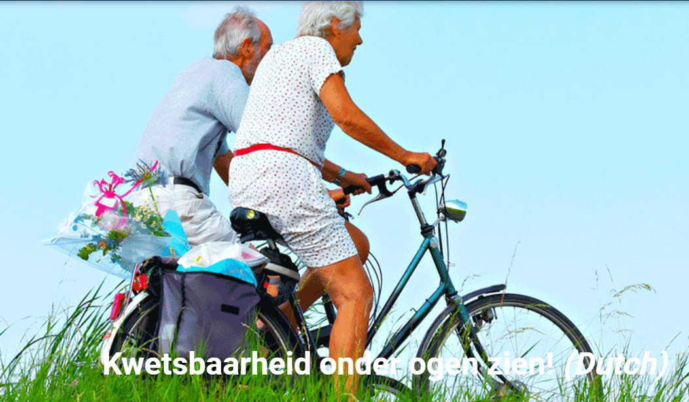 | - Photos of older people tackling frailty and your own language #faceuptofrailty hashtag.

Short stories
Short stories (1/2 page) about best practices from your community regarding the management of frailty.
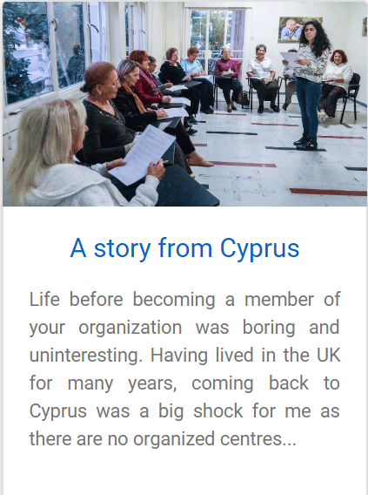
Click here to read the story.

Other

- Video-document the life of an elderly person facing up to frailty – what are the activities that he/she are doing to avoid frailty.
- Newsletters regarding the #faceuptofrailty Campaign with general information about frailty and ways to tackle frailty in order to raise awareness in MS countries.

Face Up to Frailty dissemination materials
Other dissemination materials have been developed that partners and other organisations can use for the campaign:
- Photowall (Annex 3)
- Posters (Annex 4)
- QR code (Annex 5)

Dissemination of the material produced by the partners

Join our Face Up to Frailty campaign to share and make a difference!!

For ADVANTAGE JA Partners: Your involvement in dissemination activities is highly important for the success of the campaign! WP2 alone cannot reach the target groups (policy makers, people living with frailty, informal carers, health professional and researchers) without your support, so for the success of the campaign we kindly request your constant involvement (5 minutes every two 2-3 days) in order to share the commonly created content among your network (stakeholders, professional network, people living with frailty).
For involved institutions: Your collaborative involvement to support the dissemination of Face Up To Frailty is very important for the success and impact of the campaign. To share the commonly created content among your networks, we are relying on your support to reach the target groups (People living with frailty, their carers, health and social professionals, policy makers, etc.) and beyond to enhance the spread and sharing of people with lived experiences, their carers and families and the cross sector workforce.

Notes:
- All received material will be uploaded on the ADVANTAGE JA website and social media posts will be created in order to properly disseminate the activities of the campaign.

- An organisation may wish to take the guidelines as a reference document and amend them to their local context. Please, be aware that you will need to acknowledged ADVANTAGE JA if the guidelines are adapted to your local context.

Campaign website:
link to #faceuptofrailty page

Annex 1 – Logo translations
Translations of the logo FaceUp to Frailty! in the partners` languages:

Bulgarian | да се справим с крехкото здраве!
Croatia | Pobijedimo fragilnost!
Dutch | Kwetsbaarheid onder ogen zien!
English | Face up to frailty!
Finnish | Havaitse ja huomioi iäkkään hauraus!
French | Faire face à la fragilité!
German | Selbstständigkeit im Alter – Deine Chance!
Greek | Αντιμετώπισε την ευπάθεια!
Hungarian | Szembe kell néznie a gyengeséggel!
Italian | Affrontiamo la fragilità!
Lithuanian | Susiduria su silpnumu!
Norwegian | Står opp til svakhet!
Polish | Zmierz się z kruchością!
Portuguese | Enfrentar a fragilidade!
Romanian | Confruntă fragilitatea!
Slovenian | Soočimo se s krhkostjo!
Spanish | Plantale cara a la fragilidad!

Annex 2 – Example letter
Dear ………,
Thank you very much for accepting our invitation and contributing to the ADVANTAGE JA.
ADVANTAGE (www.advantageja.eu) is a Joint Action with 22 Member States (MS) and 33 organizations involved. It is co-funded by the European Union and the MS.
Partners are working together to summarize the current State of the Art of the different components of frailty and its management, both at a personal and population level, to increase the knowledge in the field of frailty, and to build a common understanding to be used by participating MSs. The final output is the “Frailty prevention approach” (FPA) document, which is a common European model to tackle frailty of older people within a common European framework. It illustrates what should be prioritized in the next few years at European, National and Regional level and on which to base a common management approach of older people who live with frailty or are at risk of developing frailty in the European Union. The identification of the core components of frailty and its management should promote the needed changes in the organization and the implementation of the health and social systems in Europe, within a common framework.
ADVANTAGE JA addresses (a) policy makers involved in planning and developing health and social care policies and strategies for older people, (b) health and social care professionals who implement the necessary changes into the everyday practice, (c) formal and informal carers, (d) older people who live with frailty, or those at risk of frailty, (e) as well as European citizens at large.
In order to increase the awareness and the understanding about frailty, ADVANTAGE JA is currently interviewing experts in the field, who come from different backgrounds (e.g., care professionals, policy makers, researchers, academics, citizen associations, etc.) and can contribute to enhance further the value of our Joint Action. Also, we believe this will allow the ADVANTAGE JA to establish connections with more relevant national and international initiatives which are currently dealing with frailty. We would therefore strongly value your expert point of view on frailty-related issues and any information on the initiatives, projects, etc. you are currently involved in or know about. The interviews will be published on the website and linked on ADVANTAGE JA social media (i.e. Facebook, Twitter and LinkedIn).
In the next page, you will find a list of questions we would like you to answer. We recommend answering between 3 and 5 questions according to your interests and expertise, but of course any contribution is of great value to us. Please feel free to use this document for writing down your answers. For any questions you might have, please do not hesitate to contact (name of person to contact), (email address of person to contact).
Looking forward to knowing more about your expert opinion.

Best regards,
ADVANTAGE JA team

Annex 3 – Photowall

Annex 4 – Posters
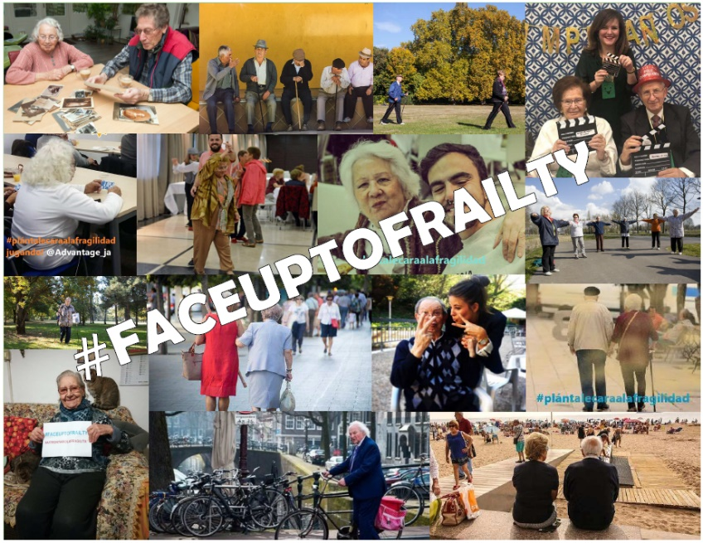
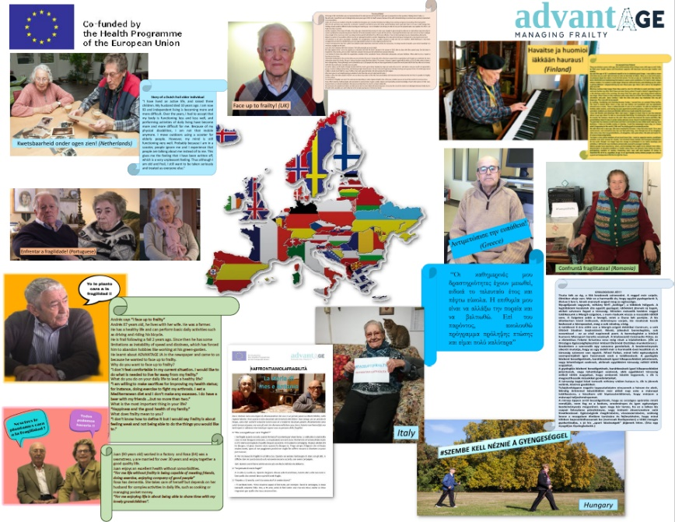

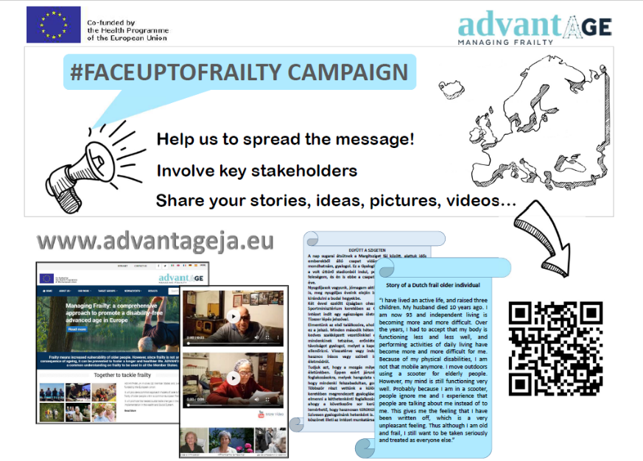
The high-quality document for printable purposes are available on the ADVANTAGE JA intranet for download.

Annex 5 – QR code leaflet
