INTERNATIONAL CONFERENCE, PROJECT MEETING

& STUDY VISITS IN MILAN

Milan, 19 – 21 March 2018
January 2018

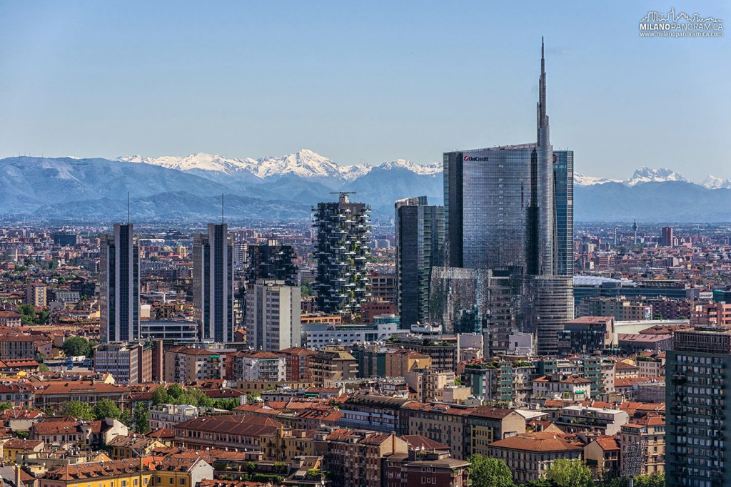

Hotel Recommendation

Following hotels have offered rooms at a special price. Since hotels in Milan are in high demand and single rooms are limited, we suggest to book as soon as possible.

-------- Please book your HOTEL individually via email, giving the password FORGET HERITAGE ------

Near Regione Lombardia and Central Station:
Hotel Marconi ****, Via F. Filzi 3, Tel +39 02.66985561 – www.marconihotel.it
€ 105 single room - € 120 double room for one person, BB (10 rooms reserved up to 26yh February)
Reservations: Tel: +39 02.66985561, e-mail: info@marconihotel.it

Hotel Baviera ****, Via Panfilo Castaldi 7, Tel +39 02.6590551 – www.mokinba.it
€ 110 single room - € 130 double room for one person, € 160 double room, BB
Reservations: tel. +39 02.6590551, e-mail: baviera@mokinba.it

UNA Hotel Century ****
Via Fabio Filzi 25/B, Tel +39 02.675041 – www.unahotels.it
€ 140 double room for one person, BB (30 rooms reserved up to 5th March)
Reservations: tel. 02.69826982 or 02.675041, e-mail: booking@gruppouna.it

In the city center:
Hotel Palazzo delle Stelline ***, Corso Magenta 61, Tel +39 02.4818431 – www.hotelpalazzostelline.it
€ 110 single room - € 125 Double room for one person, BB
Reservations: fill in the enclosed form and send to: info@hotelpalazzostelline.it

To add: Tourist tax € 4 for ***hotels and € 5 for ****hotels per day.

- - - -

Other hotels near Regione Lombardia and Central Station:
Hotel Auriga ****
Hotel NYX ****
Spice Hotel ***

Travel

Milan airports, useful links:

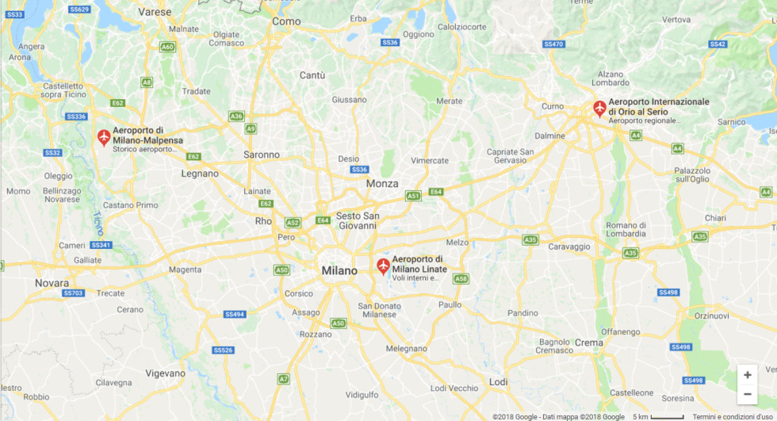

LINATE Airport
http://www.milanolinate-airport.com/it
It is located 7 km from the center; about 15 min by taxi to get to the city center or railway Central Station, cost € 55.

Easy connections to railway Central Station by coach or city center by bus
By coach to railway Central Station with departures every 30 minutes and on-board ticketing (€ 5):
STARFLY - www.starfly.net
AIR BUS (Monday through Friday) - www.milano-aeroporti.it/static/upload/ora/orariairbusxsito.pdf

By bus (public transport) to Milan Duomo M1 M3 urban line No. 73 - www.atm.it
Departures every 10 minutes, every day (€ 1,50)

MALPENSA Airport - www.milanomalpensa-airport.com/it
It is located 51 km from Milan; about 40 min, by taxi € 95

Easy connections from Terminal 1 and 2 to the railway Central Station by train or coach.

By train (30 minutes) to Milan Cadorna Station (connection by M to Central Station):
Malpensa Express - www.malpensaexpress.it (cost € 13)

By coach to Milan Central Station: 50 min. journey – departures every 20 min. – ticketing on-board (cost € 8):
TERRAVISION - www.terravision.eu
AUTOSTRADALE - www.autostradale.it
AIR PULLMAN - www.malpensashuttle.com

ORIO AL SERIO Airport (Bergamo) - www.milanbergamoairport.it
It is located 50 km from Milan; about 40 min., by taxi € 90

Easy connection to the railway Central Station by coach; 50 min. journey – departures every 20 min. – ticketing on-board (cost € 5):
TERRAVISION - www.terravision.eu
AUTOSTRADALE - https://www.autostradale.it/Images/Linee/Orari/141.pdf
ORIOSHUTTLE - www.orioshuttle.com

- - - -

MILAN CITY PASS www.milanocard.it
free public transportation, free audioguide and free or discounted entry to over 500+ Milan tourist attractions, including more than 20 top Milan museums, shops, and restaurants.

Contact
Morena Cambri - morena_cambri@regione.lombardia.it – tel. +39 02 67653324

