Wavguides list
L.p. | Length [mm] | Quantity
1 | Straight / 100 | 6
2 | Straight / 150 | 3
3 | Straight / 200 | 9
4 | Straight / 300 | 1
5 | Straight / 400 | 3
6 | Straight / 500 | 6
7 | Straight / 597 | 1
8 | Straight / 650 | 1
9 | Straight / 770 | 2
10 | Straight / 779 | 1
11 | Straight / 945 | 2
12 | Straight / 1000 | 5
13 | Straight / 1100 | 2
14 | Straight / 1500 | 10
15 | E-bend150x150 | 9
16 | H-bend 150x150 | 18
17 | 597 (flexible) | 1
18 | 770 (flexible) | 1

- L = 100, quantity = 6
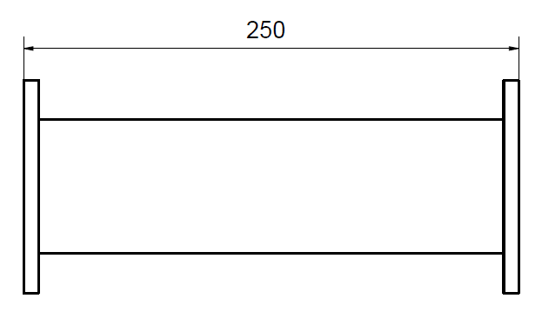
100
Mechanical Specifications
Flange type | CPR284F
 | CPR284G
Material | Brass / Copper
Outside finish | Anticorrosin grey paint
Weight ± 20% | 1,452 kg
Frequency range | 2.6-3.95 GHz
VSWR (Max) | 1,10
Peak power up to | up to 7,5 MW
Ave. Power up to | up to 20kW
Pulse lenght up to | up to 12 us
PRF up to | up to 300Hz
Dielectric gas | SF6 pressure 3bar

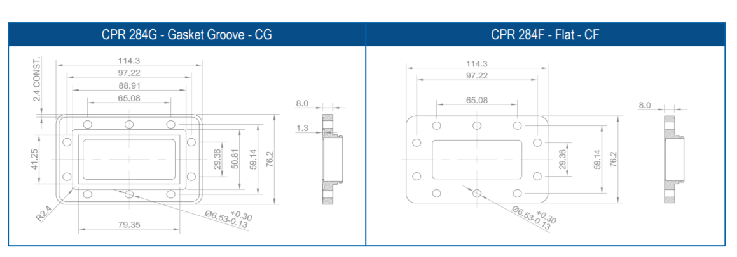
- L = 150, quantity = 3
150
Mechanical Specifications
Flange type | CPR284F
 | CPR284G
Material | Brass / Copper
Outside finish | Anticorrosin grey paint
Weight ± 20% | 1,7 kg
Frequency range | 2.6-3.95 GHz
VSWR (Max) | 1,10
Peak power | up to 7,5 MW
Ave. Power | up to 20kW
Pulse lenght | up to 12 us
PRF | up to 300Hz
Dielectric gas | SF6 pressure 3bar
- L = 200, quantity = 9
200
Mechanical Specifications
Flange type | CPR284F
 | CPR284G
Material | Brass / Copper
Outside finish | Anticorrosin grey paint
Weight ± 20% | 2 kg
Frequency range | 2.6-3.95 GHz
VSWR (Max) | 1,10
Peak power | up to 7,5 MW
Ave. Power | up to 20kW
Pulse lenght | up to 12 us
PRF | up to 300Hz
Dielectric gas | SF6 pressure 3bar

- L = 300, quantity = 1
300
Mechanical Specifications
Flange type | CPR284F
 | CPR284G
Material | Brass / Copper
Outside finish | Anticorrosin grey paint
Frequency range | 2.6-3.95 GHz
VSWR (Max) | 1,10
Weight | 2,6 kg
Peak power | up to 7,5 MW
Ave. Power | up to 20kW
Pulse lenght | up to 12 us
PRF | up to 300Hz
Dielectric gas | SF6 pressure 3bar

- L = 400, quantity = 3
400
Mechanical Specifications
Flange type | CPR284F
 | CPR284G
Material | Brass / Copper
Outside finish | Anticorrosin grey paint
Weight ± 20% | 3,2 kg
Frequency range | 2.6-3.95 GHz
VSWR (Max) | 1,10
Peak power | up to 7,5 MW
Ave. Power | up to 20kW
Pulse lenght | up to 12 us
PRF | up to 300Hz
Dielectric gas | SF6 pressure 3bar
- L = 500, quantity = 6
500
Mechanical Specifications
Flange type | CPR284F
 | CPR284G
Material | Brass / Copper
Outside finish | Anticorrosin grey paint
Weight ± 20% | 3,8 kg
Frequency range | 2.6-3.95 GHz
VSWR (Max) | 1,10
Peak power | up to 7,5 MW
Ave. Power | up to 20kW
Pulse lenght | up to 12 us
PRF | up to 300Hz
Dielectric gas | SF6 pressure 3bar

- L = 597, quantity = 1
597
Mechanical Specifications
Flange type | CPR284F
 | CPR284G
Material | Brass / Copper
Outside finish | Anticorrosin grey paint
Weight ± 20% | 4,4 kg
Frequency range | 2.6-3.95 GHz
VSWR (Max) | 1,10
Peak power | up to 7,5 MW
Ave. Power | up to 20kW
Pulse lenght | up to 12 us
PRF | up to 300Hz
Dielectric gas | SF6 pressure 3bar

- L = 650, quantity = 1
650
Mechanical Specifications
Flange type | CPR284F
 | CPR284G
Material | Brass / Copper
Outside finish | Anticorrosin grey paint
Weight ± 20% | 4,7 kg
Frequency range | 2.6-3.95 GHz
VSWR (Max) | 1,10
Peak power | up to 7,5 MW
Ave. Power | up to 20kW
Pulse lenght | up to 12 us
PRF | up to 300Hz
Dielectric gas | SF6 pressure 3bar

- L = 770, quantity = 2
770
Mechanical Specifications
Flange type | CPR284F
 | CPR284G
Material | Brass / Copper
Outside finish | Anticorrosin grey paint
Weight ± 20% | 5,4 kg
Frequency range | 2.6-3.95 GHz
VSWR (Max) | 1,10
Peak power | up to 7,5 MW
Ave. Power | up to 20kW
Pulse lenght | up to 12 us
PRF | up to 300Hz
Dielectric gas | SF6 pressure 3bar

- L = 779, quantity = 1
779
Mechanical Specifications
Flange type | CPR284F
 | CPR284G
Material | Brass / Copper
Outside finish | Anticorrosin grey paint
Weight ± 20% | 5,5 kg
Frequency range | 2.6-3.95 GHz
VSWR (Max) | 1,10
Peak power | up to 7,5 MW
Ave. Power | up to 20kW
Pulse lenght | up to 12 us
PRF | up to 300Hz
Dielectric gas | SF6 pressure 3bar

- L = 945, quantity = 2
945
Mechanical Specifications
Flange type | CPR284F
 | CPR284G
Material | Brass / Copper
Outside finish | Anticorrosin grey paint
Weight ± 20% | 6,5 kg
Frequency range | 2.6-3.95 GHz
VSWR (Max) | 1,10
Peak power | up to 7,5 MW
Ave. Power | up to 20kW
Pulse lenght | up to 12 us
PRF | up to 300Hz
Dielectric gas | SF6 pressure 3bar
- L = 1000, quantity = 5
1000
Mechanical Specifications
Flange type | CPR284F
 | CPR284G
Material | Brass / Copper
Outside finish | Anticorrosin grey paint
Weight ± 20% | 6,8 kg
Frequency range | 2.6-3.95 GHz
VSWR (Max) | 1,10
Peak power | up to 7,5 MW
Ave. Power | up to 20kW
Pulse lenght | up to 12 us
PRF | up to 300Hz
Dielectric gas | SF6 pressure 3bar

- L = 1100, quantity = 2
1100
Mechanical Specifications
Flange type | CPR284F
 | CPR284G
Material | Brass / Copper
Outside finish | Anticorrosin grey paint
Weight ± 20% | 7,4 kg
Frequency range | 2.6-3.95 GHz
VSWR (Max) | 1,10
Peak power | up to 7,5 MW
Ave. Power | up to 20kW
Pulse lenght | up to 12 us
PRF | up to 300Hz
Dielectric gas | SF6 pressure 3bar

- L = 1500, quantity = 10
1500
Mechanical Specifications
Flange type | CPR284F
 | CPR284G
Material | Brass / Copper
Outside finish | Anticorrosin grey paint
Weight ± 20% | 9,8 kg
Frequency range | 2.6-3.95 GHz
VSWR (Max) | 1,10
Peak power | up to 7,5 MW
Ave. Power | up to 20kW
Pulse lenght | up to 12 us
PRF | up to 300Hz
Dielectric gas | SF6 pressure 3bar
- E-bend, quantity = 9

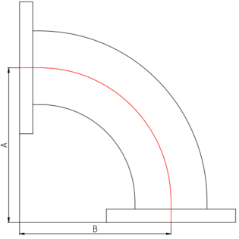
A = 150
B = 150

Mechanical Specifications
Flange type | CPR284F
 | CPR284G
Material | Brass / Copper
Outside finish | Anticorrosin grey paint
Weight ± 20% | 2,2 kg
Frequency range | 2.6-3.95 GHz
VSWR (Max) | 1,10
Peak power | up to 7,5 MW
Ave. Power | up to 20kW
Pulse lenght | up to 12 us
PRF | up to 300Hz
Dielectric gas | SF6 pressure 3bar

- H-bend, quantity = 18
A = 150
B = 150
Mechanical Specifications
Flange type | CPR284F
 | CPR284G
Material | Brass / Copper
Outside finish | Anticorrosin grey paint
Weight ± 20% | 2,2 kg
Frequency range | 2.6-3.95 GHz
VSWR (Max) | 1,10
Peak power | up to 7,5 MW
Ave. Power | up to 20kW
Pulse lenght | up to 12 us
PRF | up to 300Hz
Dielectric gas | SF6 pressure 3bar

- Flexible waveguide L = 597, quantity = 1

597
Mechanical Specifications
Flange type | CPR284F
 | CPR284G
Material | Brass / Copper
Peak power | up to 2,2 MW
Ave. Power | up to 5kW
PRF | up to 150Hz

- Flexible waveguide L = 770, quantity = 1
770
Mechanical Specifications
Flange type | CPR284F
 | CPR284G
Material | Brass / Copper
Peak power | up to 2,2 MW
Ave. Power | up to 5kW
PRF | up to 150Hz

