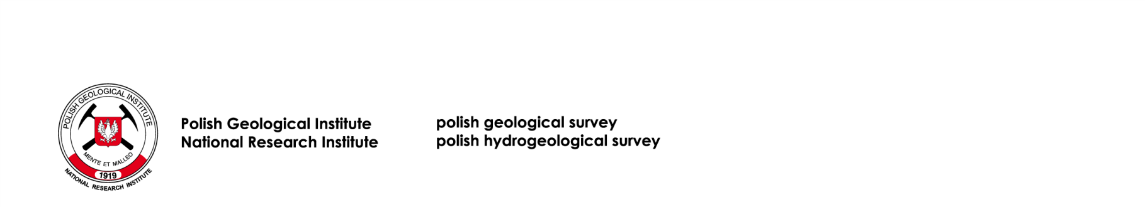

Warsaw, 16 September 2021

It concerns a public procurement procedure for Supply of software licences for two-dimensional and three-dimensional restoration of deep geological structure models, Case No.: EZP.26.112.2021

CHANGE OF CONTENT OF TERMS OF REFERENCE

Państwowy Instytut Geologiczny - Państwowy Instytut Badawczy [Polish Geological Institute - National Research Institute], acting pursuant to Art. 286 paragraph. 1 in connection with Art. 284 paragraph. 3 of the Act of 11 September 2019 - Public Procurement Law (Dz. U. /Journal Of Laws/ of 2021, items 1129 as amended), informs that it changes the content of the Terms of Reference in the scope of:

1. Deadline for submitting offers:
1) Point 16.2 of the ToR is changed, being replaced by:
“The bid submission deadline is 23 September 2021 at 12:00 p.m.”

2) Point 16.3 of the ToR is changed, being replaced by:
“The bid opening date is 23 September 2021 at 12:05 p.m.”

2. Point 15 of the ToR is changed, being replaced by:
“The Contractor shall remain bound by the bid for 30 days, i.e. until 22 october 2021. The bid validity period shall begin upon the expiry of the bid submission deadline”.

The other remaining ToR remain unchanged.

As a consequence of change to the content of the ToR, the Contracting Authority has changed the content of the Announcement of Supply procurement. Announcement of the change of Announcement of Supply procurement has been published in Public Procurement Bulletin on September 16, 2021.

Plenipotentiary of the Director of PGI-NRI
Public Procurement Office
Mariola Siwek

