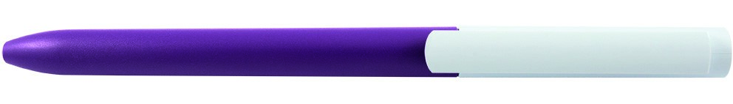

Logo:

Colour:

Size imprint:

W: 24,7mm

H: 6mm

Pantone: UV

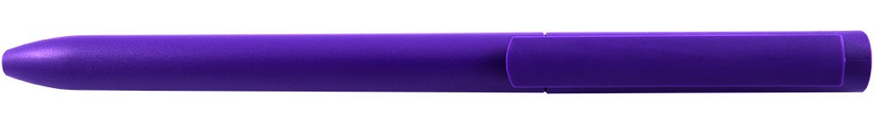

Logo:

Colour:

Size imprint:

W: 24,7mm

H: 6mm

Pantone: UV