Haix Tactical 2.0 GTX mid
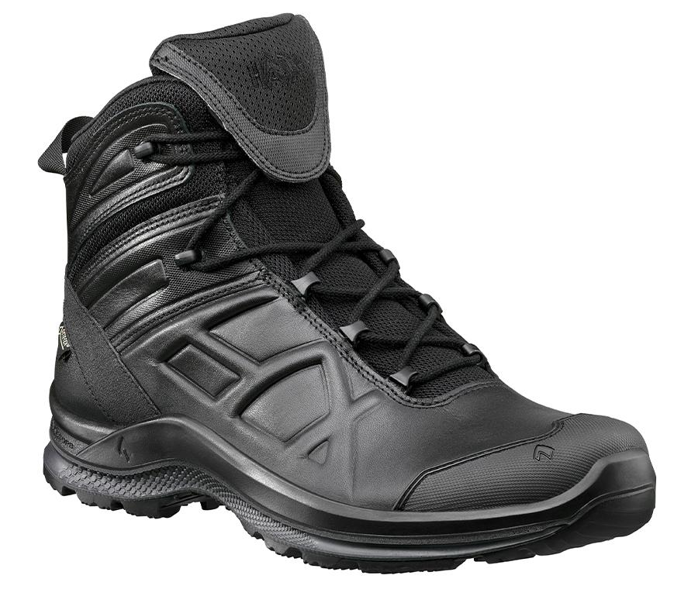

Haix Athletic 2.1 GTX mid
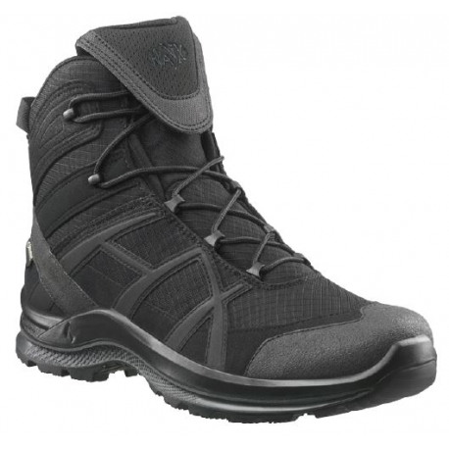

Haix Athletic 2.1 GTX low
